**PROJECT-1:EXHAUSTIVE ANALYSIS OF INDIAN AGRICULTURE**

WEEK-1 TASK

STEP-1:open the powerbi app and click on GET DATA for analysis

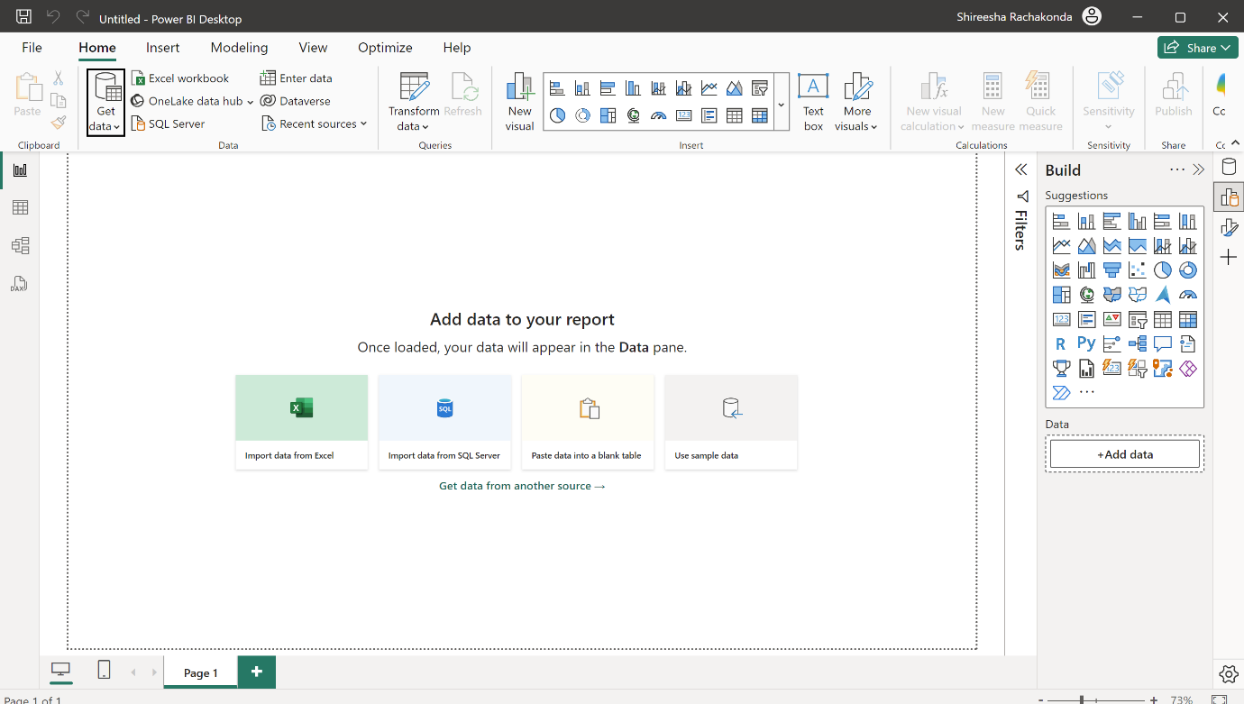

Step-2:from get data click on TEXT CSV to upload a document.then the document is displays in screen with 3 options {LOAD,TRANSFORM AND CANCEL}

LOAD is used when the data is cleaned

TRANSFORM is used when we want to process the data.

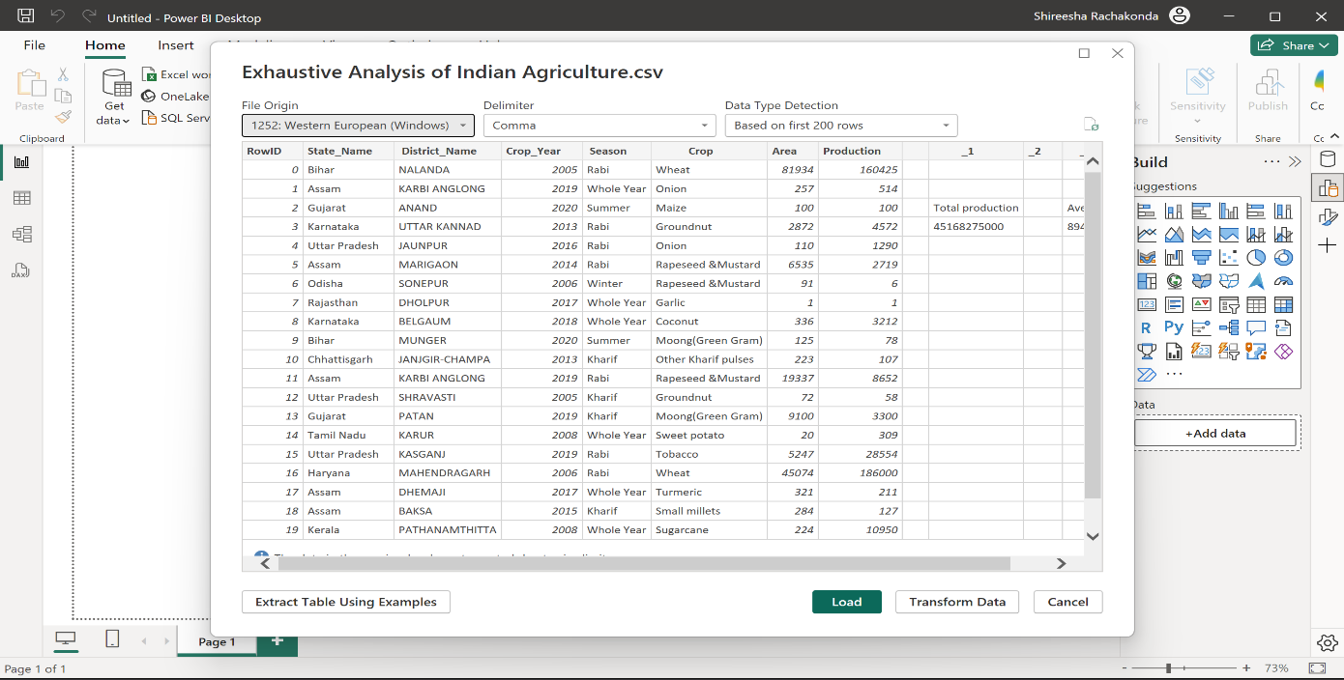

Step-3:click on TRANSFORM DATA to process the data

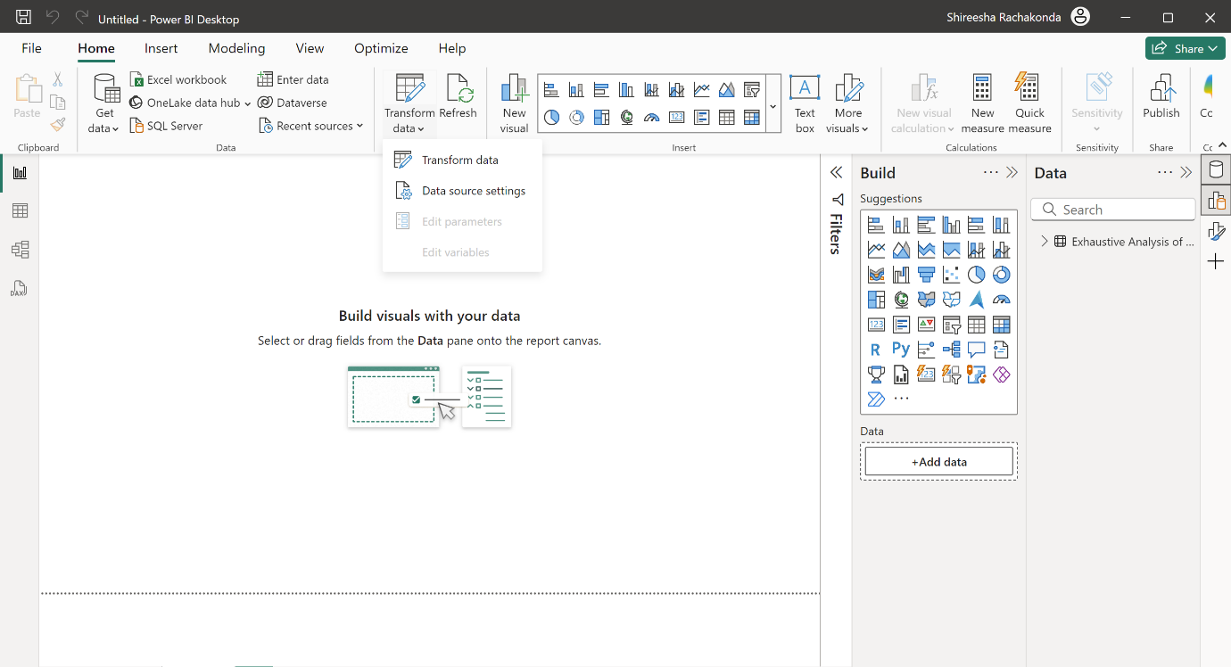

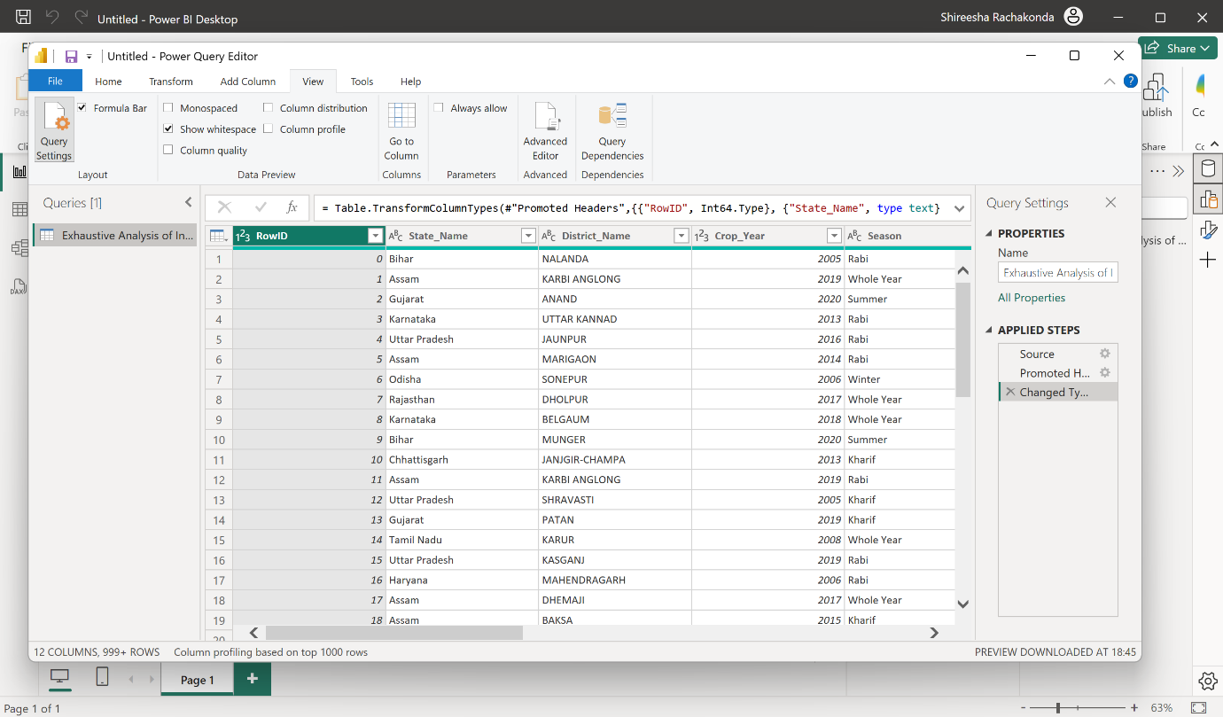

Step-4:delete the unwanted columns(which doesn’t contain any data)

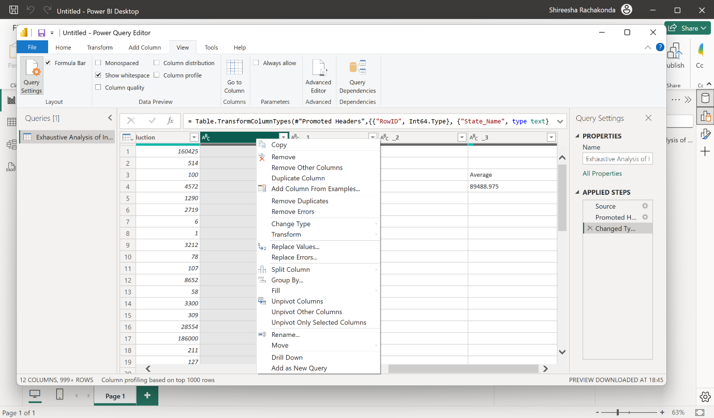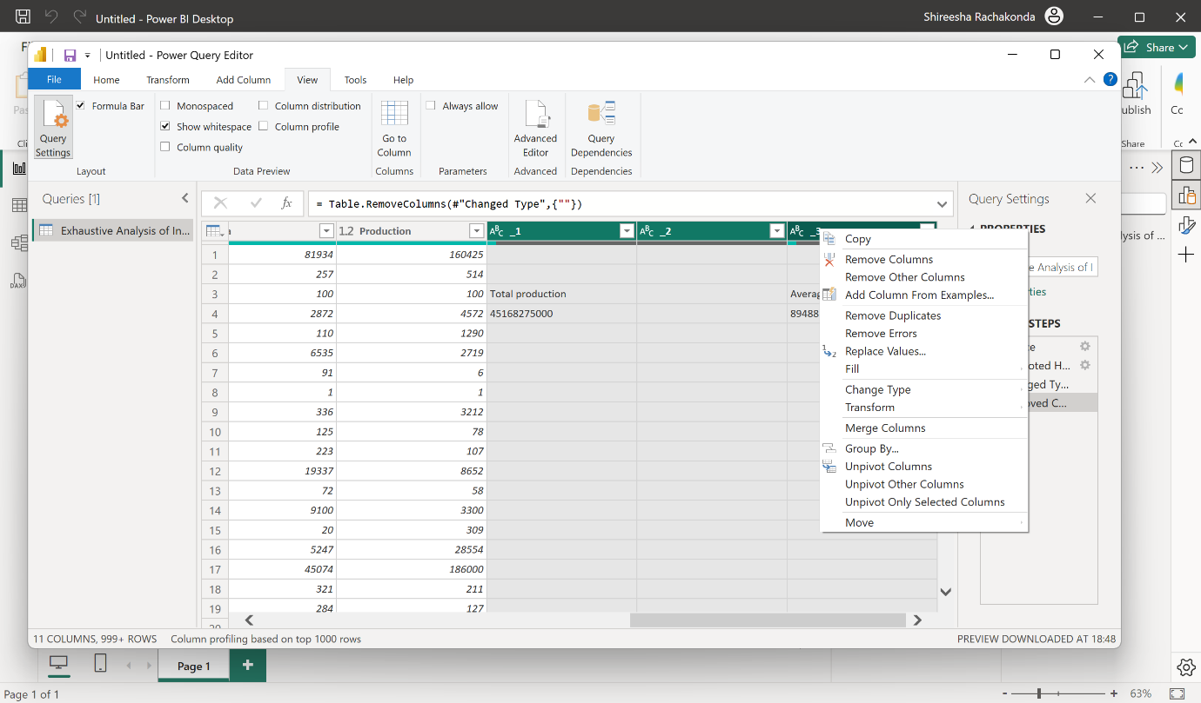

Deleted cells will be recovered through clicking on removed cells option

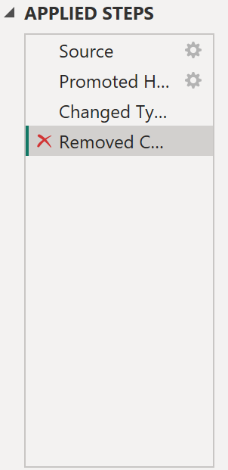

Step-5:after processing the data click on close and apply then the transformed data is appeared on actual dashboard

